-Unit 2-
POPULATION AND MIGRATION
Unit 2 will cover the following topics outlined by College Board (Chapters 2 & 3 in textbook)
2.1 – Population Distribution | 2.2 – Consequences of Population Distribution
2.3 – Population Composition | 2.4 – Population Dynamics
2.5 – The Demographic Transition Model | 2.6 – Malthusian Theory
2.7 – Population Policies | 2.8 – Women and Demographic Change
2.9 – Aging Populations | - – Causes of Migration
2.11 – Forced and Voluntary Migration | 2.12 – Effects of Migration

1) Why do people live where they do? What are the most popular locations? Why?

2) What is Carrying Capacity? What does it explain about population?

3) Fill out the following chart:
Type of Density | How Does it Work? | What does it explain? Example?
Arithmetic

Physiological

Agricultural

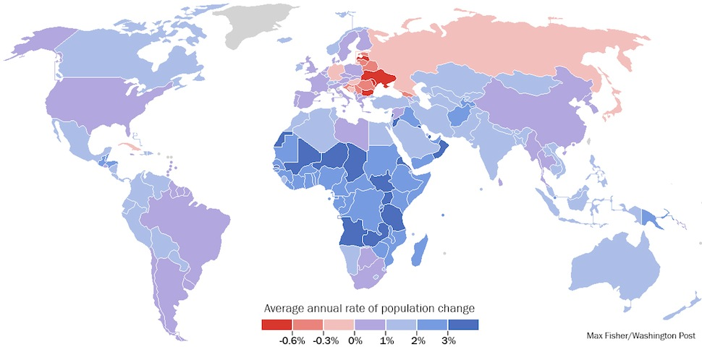
4) By analyzing the map above, what conclusions can be made about the population of the world?
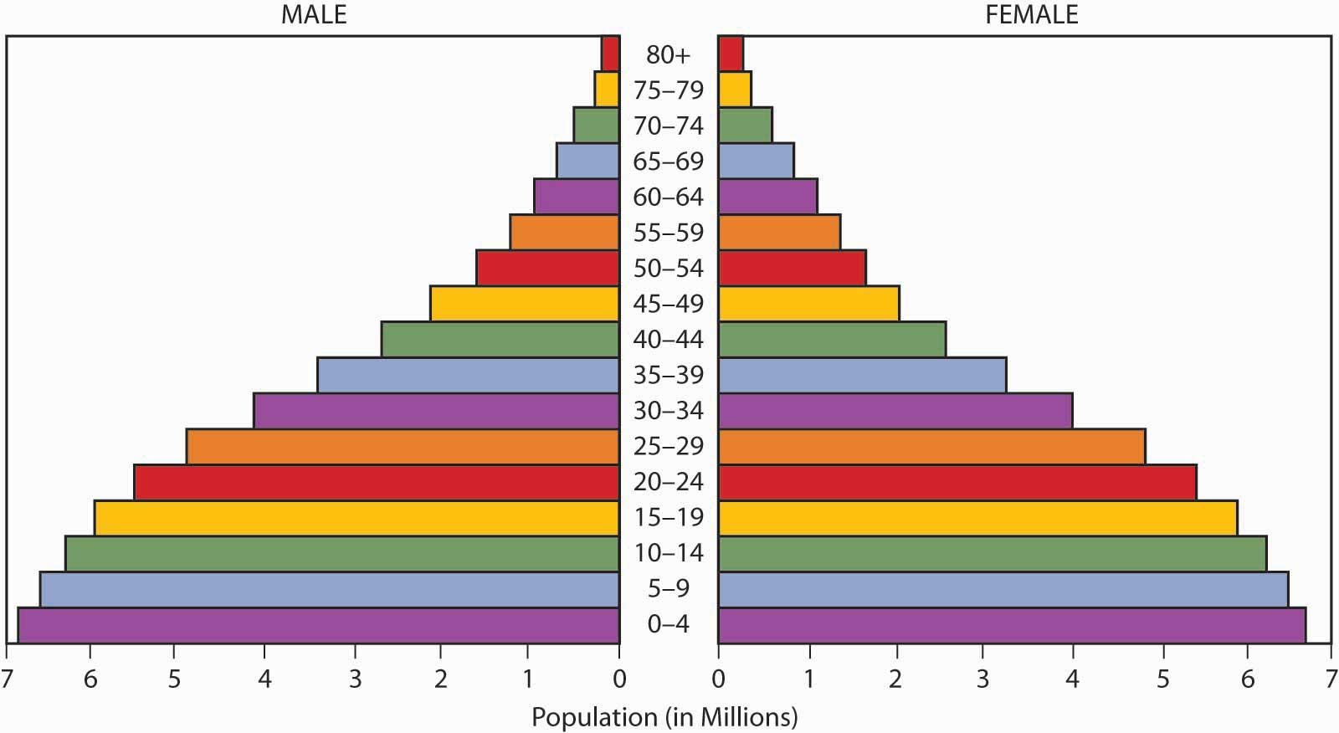
5) Label each part of the population pyramid above.

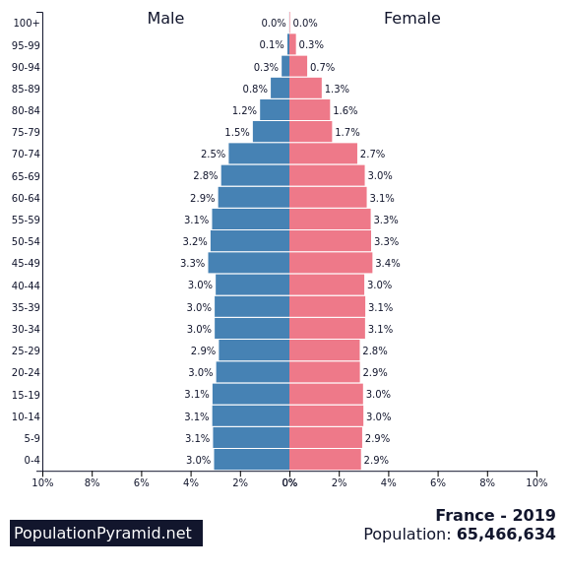
6) What conclusions can be made about France’s population based on the pyramid to the right?

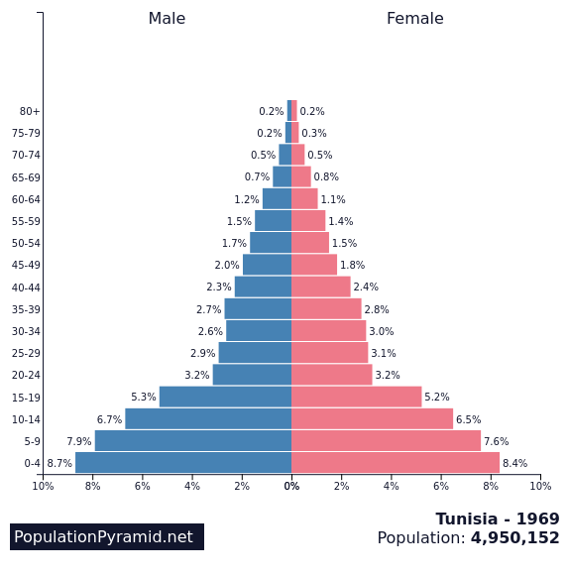
7) What conclusions can be made about Tunisia’s population based on the pyramid to the right?

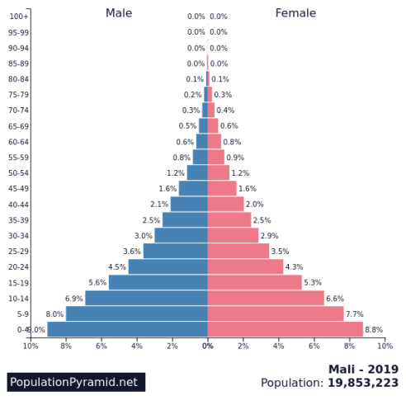
8) What conclusions can be made about Mali’s population based on the pyramid to the right?

9) Understanding Population Statistics. Know the differences between each.
Statistic | Definition | What Can It Tell About a Population?
CBR

CDR

TFR

IMR

NIR or Rate of Natural Increase

10) Draw and Label the Demographic Transition Model
Stage | Stage | Stage | Stage | Stage

11) What did Thomas Malthus’ ultimately envision would happen to humanity? Explain why his vision did not come to fruition?

12) Types of migration/immigration:
Type | How It Functions | Examples
Voluntary

Emigration

Immigration

Internal

Interregional

Intraregional

Forced

Chain

Step

13) Push/Pull Factors
Push | Type | Pull
 | Political
 | Economic
 | Environmental

14) Immigration to the US timeline. What parts of the world did majority of immigrants come from during each of the time periods?
BE SPECIFIC!!!

American Rev Civil War 1900 World Wars 1950s 1970s +

15) List the characteristics of each:
Refugee | Internally Displaced Person (IDP) | Asylum Seeker

16) Commonly Confused Vocabulary Pairs for Unit 2
- birth rate vs. natural increase rate
- pandemic vs. epidemic
- immigrant vs. emigrant
- internally displaced person (IDP) vs. refugee vs. asylum seeker (see above)
- chain vs. step migration
Note any other information we discussed in class that is not represented above.

