-Unit 3-
CULTURE
Unit 2 will cover the following topics outlined by College Board (Chapters 4, 5, 6, & 7 in textbook)

1) What is culture?

2) Identify characteristics of each:

a) Folk

b) Popular

3) What is a cultural hearth and where are they located?

4) Explain how ethnocentrism influences interaction with other cultures. Provide two (2) SPECIFIC examples.

5) What is a cultural landscape?

6) Describe three of your cultural landscapes with SPECIFIC characteristics
Home

Neighborhood

City you live in

7) Cite and explain, with SPECIFIC examples, three (3) parts of culture that can be reflected in a cultural landscape.

8) Explain the following terms and provide a SPECIFIC example:
Ethnic Neighborhood

Gendered Spaces

Syncretism

Assimilation

Acculturation

Multiculturalism

9) Identify two (2) SPECIFIC examples related to culture for each type of diffusion:
Relocation

Contagious

Hierarchical

Stimulus

10) How does language diffuse?

11) Draw the Indo-European Language Tree (Include the 5 branches and the 2 largest leaves for each branch):

12) Identify two (2) endangered languages and ways they can be saved.

13) Explain the difference between a dialect and a language and provide two (2) examples.

14) Identify the lingua franca of international business.

15) Complete the chart about the 5 major world religions
Religion | Location of Origin | Universalizing or Ethnic?

Define Ethnic religion:

Define Universalizing religion:

20) Identify and explain three (3) examples of religious diffusion.

21) Define sacred space and provide a SPECIFIC example of a sacred space for each of the five major world religions.

For each of the following maps, answer the four questions:

What? What does the map actually show – use map title, key, data on or around map, date, numbers, and words. EVERYTHING listed on the map is important.

Where? Look for regions or patterns in the distribution of phenomena on the map. Think about areas of high density, pockets of low density, patterns or lack of patterns, etc.

Why There? Explain reasons for the pattern or location to be as it is. Use SPECIFIC historical, political, geographic, or economic examples in your explanation.

So What? Questions to ask yourself about the map:
• What questions did you have about the data portrayed on the map?
• What was most interesting about it?
• Does the map raise any concerns?
• How would you summarize the message or importance of this map?
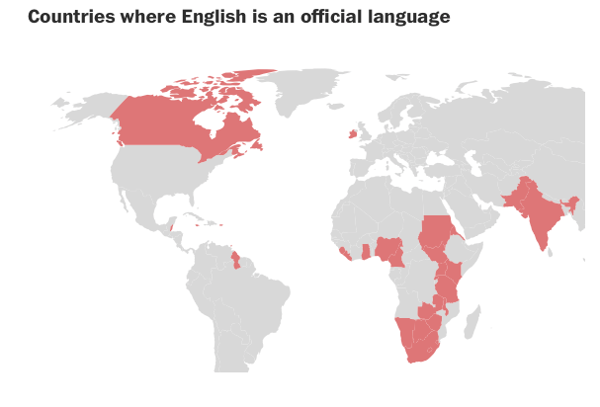

What?

Where?

Why there?

So What?
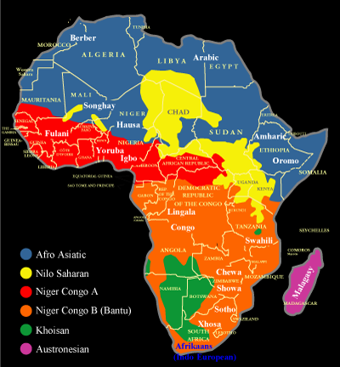

What?

Where?

Why there?

So What?

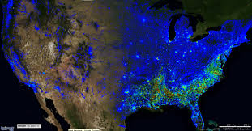

What?

Where?

Why there?

So What?

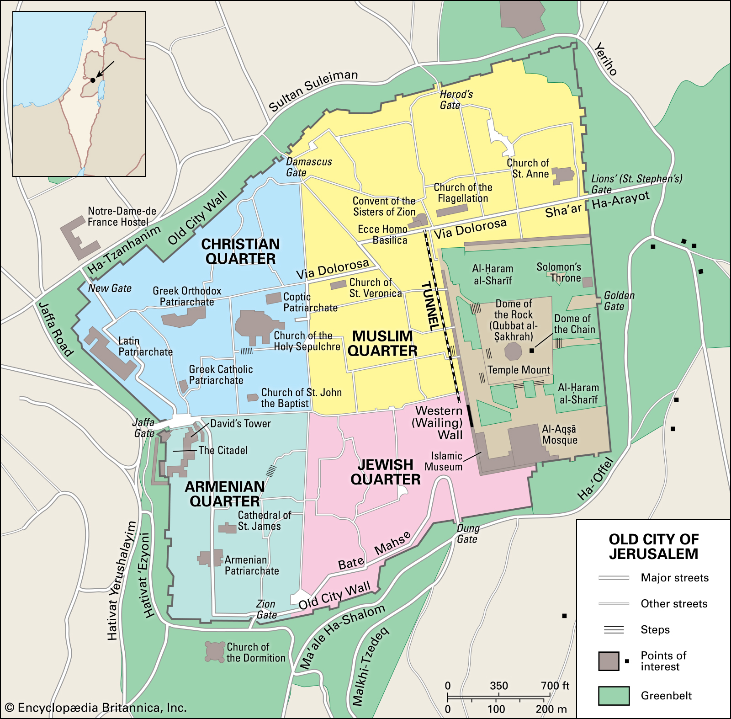
What?

Where?

Why there?

So What?

