UNIT 4
POLITICAL PATTERNS AND PROCESSES

1) Describe the characteristics needed to be a state.

2) Complete the chart:
Type of states | Definition | Real World Example(s)
Nations

Nation-state

Stateless nation

Multi nation states

Multi state nations

Autonomous regions

Semi-autonomous regions

3a) Explain the influence of colonialism and imperialism on political boundaries as a whole.

3b) Explain how imperialism and decolonization has/is still affecting one SPECIFIC part of the world.

4) Complete the chart:
Boundary Type | Definition | SPECIFIC Example(s)
Relic | Old, leftover boundary that is not used anymore
Superimposed | Forced onto the land without thought to existing cultural, linguistic, or political boundaries
Subsequent | Developed after people have settled in area and be adjusted as cultural landscape shifts
Antecedent | Decided long before settlements were in the area
Geometric | Most often straight lines (humans love straight lines) drawn regardless of what is there
Consequent | Borders that follow cultural divides like, ethnicity, language, religion, etc.

5) Boundary Disputes Chart
Category | Definition of Dispute | SPECIFIC Example(s)
Definitional

Delimited

Demarcated

Operational

Allocational

6) UNCLOS – Label each of the interior lines (include distances).
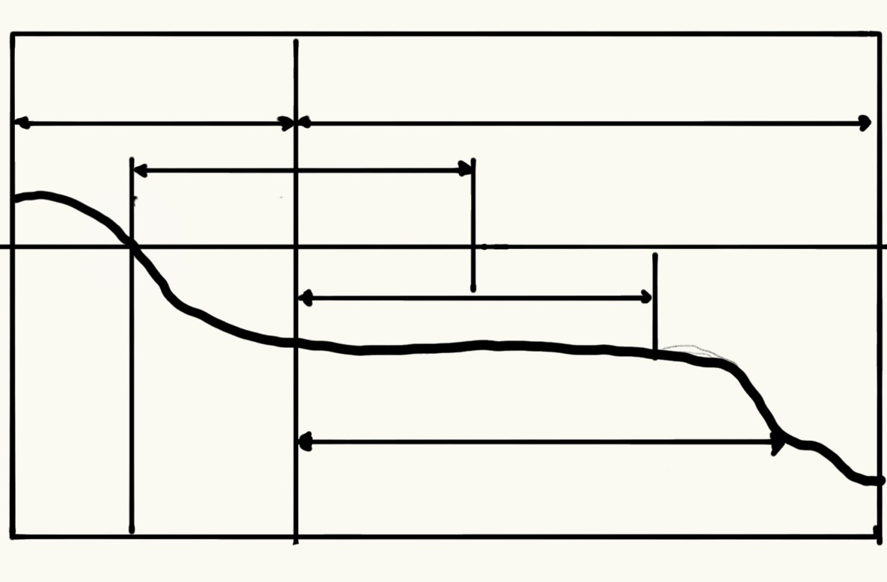

7) Create gerrymandered districts based on each type of vote below, then explain the purpose behind each gerrymandering.
Xoxxoxxoox
Xooxoxooxx
Xooxoxoxoo
Xoxooooxox
Xoxooxooox
oxxooxooxo
Xxooxooxoo
Xoxoxoxoxo
Oxxoooxxxx
xxoxxooxxo
Xoxxoxxoox
Xooxoxooxx
Xooxoxoxoo
Xoxooooxox
Xoxooxooox
oxxooxooxo
Xxooxooxoo
Xoxoxoxoxo
Oxxoooxxxx
xxoxxooxxo
Xoxxoxxoox
Xooxoxooxx
Xooxoxoxoo
Xoxooooxox
Xoxooxooox
oxxooxooxo
Xxooxooxoo
Xoxoxoxoxo
Oxxoooxxxx
xxoxxooxxo

Wasted Vote Excess Vote Stacked Vote

8) Explain the difference between a Unitary and a Federal States. Provide two (2) examples of each.

9a) Explain devolution.

9b) Citing three (3) historical examples, describe the causes of that specific devolution, and the results.

Example 1:

Example 2:

Example 3:

10) Describe Supranational Organizations and provide 2 (two) non-related examples.

10b) Explain the positives and negatives of a state being a part of a Supranational Organizations?

11a) Explain how centrifugal forces influence states in political geography

11b) Explain how centripetal forces influence states in political geography?

For each of the following maps, answer the four questions:

What? What does the map actually show – use map title, key, data on or around map, date, numbers, and words. EVERYTHING listed on the map is important.

Where? Look for regions or patterns in the distribution of phenomena on the map. Think about areas of high density, pockets of low density, patterns or lack of patterns, etc.

Why There? Explain reasons for the pattern or location to be as it is. Use SPECIFIC historical, political, geographic, or economic examples in your explanation.

So What? Questions to ask yourself about the map:
• What questions did you have about the data portrayed on the map?
• What was most interesting about it?
• Does the map raise any concerns?
• How would you summarize the message or importance of this map?

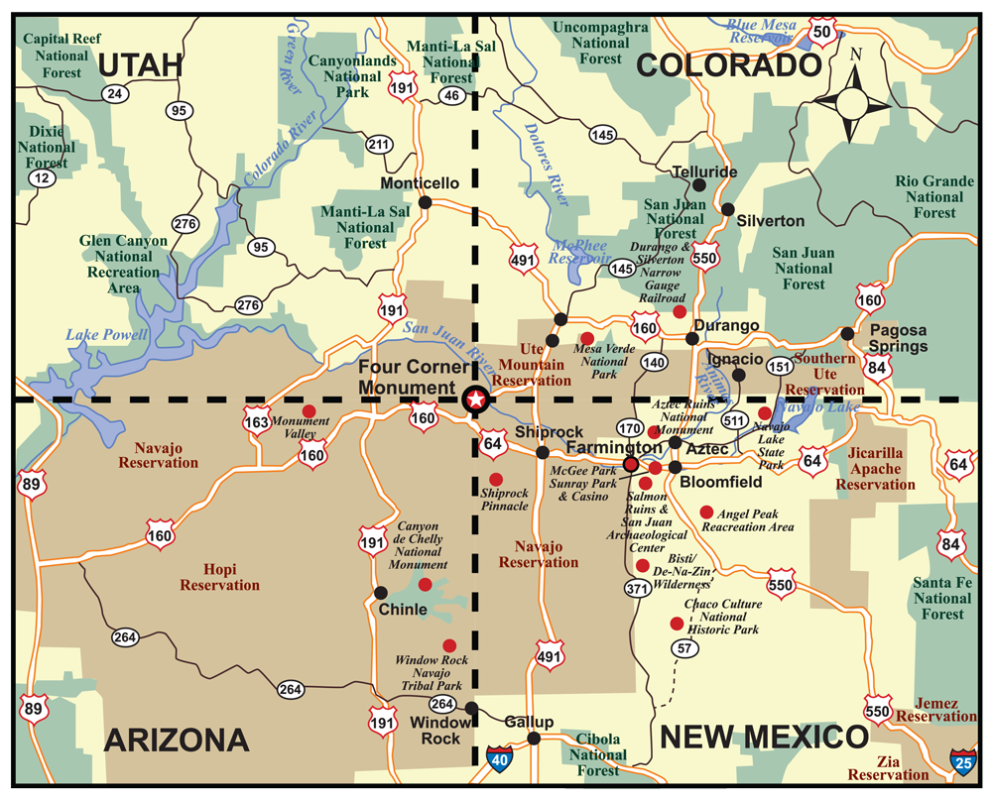

What?

Where?

Why There?

So What?
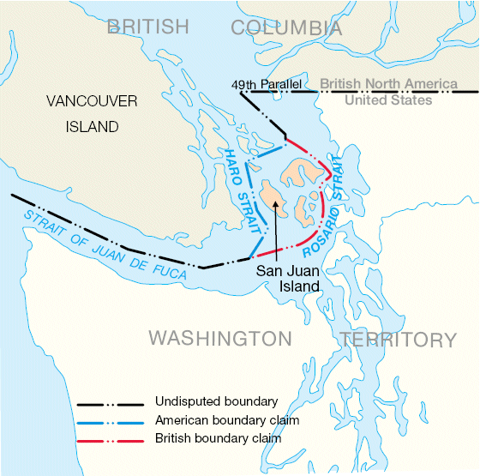

What?

Where?

Why There?

So What?

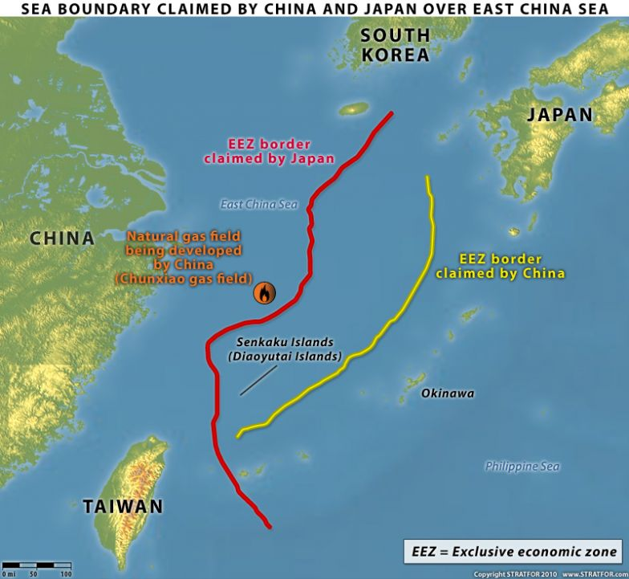
What?

Where?

Why there?

So What?

